**ROYAL VOCATION SENIOR SECONDARY SCHOOL**

**END OF YEAR ASSESSMENT 2023**

**SENIOR ONE PHYSICS**

Time 2 hours

Instructions. Attempt all

1. 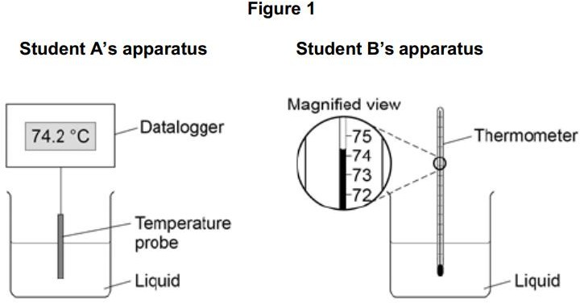In a science fare conducted at Uganda science centre in Kampala, two students investigated the change of state of stearic acid from liquid to solid They measured how the temperature of stearic acid changed over 5 minutes as it changed from liquid to solid.
   1. Choose and explain two advantages of using student A’s apparatus

(04 scores)

……………………………………………………………………………………………………

……………………………………………………………………………………………………

……………………………………………………………………………………………………

* 1. Student B was asked by the audience about how an uncalibrated thermometer can be given an accurate scale, as an s2 students describe the proper procedures that would be taken. (06 scores)

……………………………………………………………………………………………………

……………………………………………………………………………………………………

……………………………………………………………………………………………………

……………………………………………………………………………………………………

……………………………………………………………………………………………………

……………………………………………………………………………………………………

1. The diagrams show the arrangement of the particles in a solid and in a gas Each circle represents one particle.

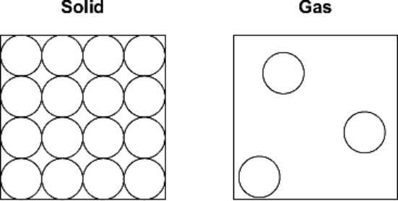

* 1. Complete the diagram below to show the arrangement of the particles in a liquid (01score)



* 1. Explain, in terms of the particles, why gases are easy to compress

(02 scores)

……………………………………………………………………………………………………

……………………………………………………………………………………………………

……………………………………………………………………………………………………

* 1. The diagram below shows the model that a science teacher used to show her students that there is a link between the temperature of a gas and the speed of the gas particles. The ball-bearings represent the gas particles. Switching the motor on makes the ball-bearings move around in all directions.

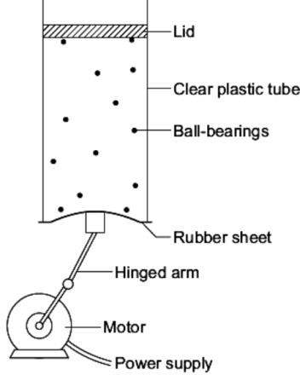

* 1. How is the motion of the ball-bearings similar to the motion of the gas particles? (03 scores)

……………………………………………………………………………………………………

……………………………………………………………………………………………………

……………………………………………………………………………………………………

* 1. The faster the motor runs, the faster the ball-bearings move. Increasing the speed of the motor is like increasing the temperature of a gas.

Use the model to predict what happens to the speed of the gas particles when the temperature of a gas is increased. (04 scores)

……………………………………………………………………………………………………

……………………………………………………………………………………………………

……………………………………………………………………………………………………

……………………………………………………………………………………………………

……………………………………………………………………………………………………

……………………………………………………………………………………………………

1. (a)The diagrams, A, B and C, show the horizontal forces acting on a moving car Draw a line to link each diagram to the description of the car's motion at the moment when the forces act

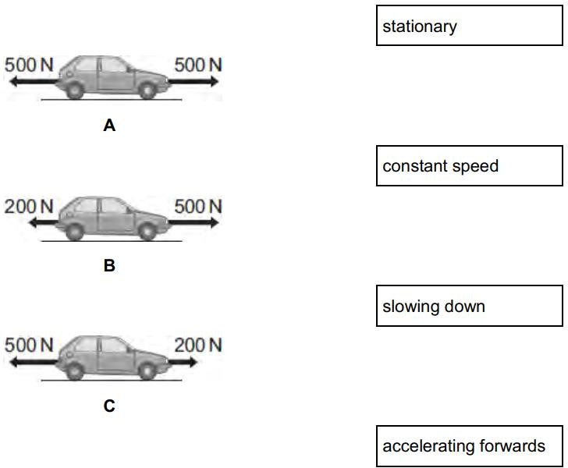Draw only three lines. (03 scores)

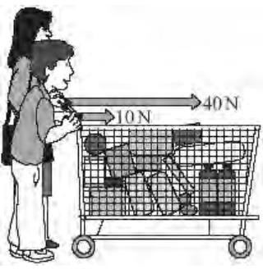(b) The diagram shows an adult and a child pushing a loaded shopping trolley

1. What is the *total force* on the trolley due to the adult and child?

(03scores)

……………………………………………………………………………………………………

……………………………………………………………………………………………………

……………………………………………………………………………………………………

1. Which one of the terms in the box means the same as total force? Draw a ring around your answer (01 score)

The trolley is pushed at a constant speed for 80 metres. Calculate the work done to push the trolley 80 metres. Show clearly how you work out your answer.(work done = force x distance ) (03 scores)

……………………………………………………………………………………………………

……………………………………………………………………………………………………

……………………………………………………………………………………………………

……………………………………………………………………………………………………

……………………………………………………………………………………………………

……………………………………………………………………………………………………

……………………………………………………………………………………………………

……………………………………………………………………………………………………

1. (a) Forces have different effects eg Use the correct

answer from the box to complete the Sentence. (01 score)



(b) Two students play a game of arm wrestling as shown below

The two students form balanced forces for over 10minutes.

1. Briefly describe the meaning of balanced forces. (03 scores)

……………………………………………………………………………………………………

……………………………………………………………………………………………………

……………………………………………………………………………………………………

1. Explain how effects of force can be useful to man in your community

(06 scores)

……………………………………………………………………………………………………

……………………………………………………………………………………………………

……………………………………………………………………………………………………

……………………………………………………………………………………………………

……………………………………………………………………………………………………

……………………………………………………………………………………………………

……………………………………………………………………………………………………

……………………………………………………………………………………………………

……………………………………………………………………………………………………

1. (a) Some objects are transparent and some objects are opaque.

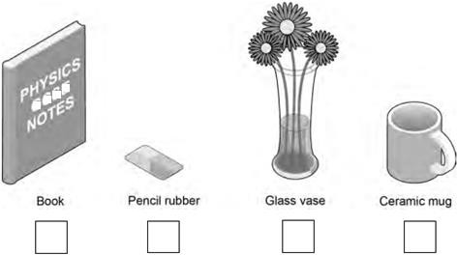Which one of the objects in Figure below is transparent? (tick in the boxes below) (02 scores)

An opaque object does not Light

Chose from **absorb, reflect, transmit.** (02 scores)

1. Rectilinear propagation of light is the process by which light rays travel in a straight line, it can be applied in a pinhole camera and eclipse. Briefly describe an experiment to show that light travels in a straight line. (06 scores)

……………………………………………………………………………………………………

……………………………………………………………………………………………………

……………………………………………………………………………………………………

……………………………………………………………………………………………………

……………………………………………………………………………………………………

……………………………………………………………………………………………………

……………………………………………………………………………………………………

……………………………………………………………………………………………………

……………………………………………………………………………………………………

1. (a) A student at Kawempe Muslim SS investigated how the type of surface affects the amount of infrared radiation box the surface absorbs; Figure below shows the equipment that the student used

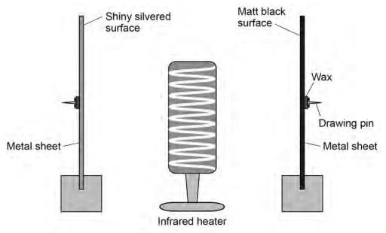

1. State what was observed after some time (01 score)

……………………………………………………………………………………………………

……………………………………………………………………………………………………

……………………………………………………………………………………………………

1. Explain your observation above (03 scores)

……………………………………………………………………………………………………

……………………………………………………………………………………………………

……………………………………………………………………………………………………

(b)(i) In 2021 in Namanve industrial area, people oftenly experience global warming, some scientist believes that its due green house effect, as a physics student briefly explain how green house effect leads to global warming

(04 scores)

……………………………………………………………………………………………………

……………………………………………………………………………………………………

……………………………………………………………………………………………………

……………………………………………………………………………………………………

……………………………………………………………………………………………………

……………………………………………………………………………………………………

……………………………………………………………………………………………………

……………………………………………………………………………………………………

……………………………………………………………………………………………………

(ii) How useful is greenhouse effect to flower glowers in your country

(02 scores)

……………………………………………………………………………………………………

……………………………………………………………………………………………………

……………………………………………………………………………………………………

……………………………………………………………………………………………………

……………………………………………………………………………………………………

……………………………………………………………………………………………………

1. (a) Imagine a student picks a glittering stone and thinks it could be gold, what procedures can you follow to confirm whether its pure gold or fake gold.

(06scores)

……………………………………………………………………………………………………

……………………………………………………………………………………………………

……………………………………………………………………………………………………

……………………………………………………………………………………………………

……………………………………………………………………………………………………

……………………………………………………………………………………………………

……………………………………………………………………………………………………

……………………………………………………………………………………………………

……………………………………………………………………………………………………

1. Figure below shows four blocks of different materials floating on water. The four blocks are of the same volume. Which of the blocks has the smallest weight?

(01 score)

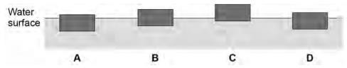

1. State what is meant by the term relative density and briefly explain why it has no SI units. (03 scores)

…………………………………………………………………………………………….

…………………………………………………………………………………………….

…………………………………………………………………………………………….

SECTION B

1. **SCENARIO**

In a remote village where medical facilities are distant, a child falls sick and is rushed to a nearby facility for medical attention. Unfortunately, the only thermometer available is worn out in that the scale readings are no longer visible and the thermometer appears unmarked to the medical assistant who attempts measure the temperature.

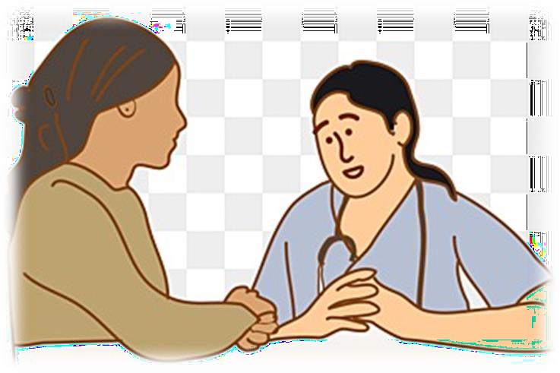

TASK

As a physics learner, describe the steps you can undertake in order to make the unmarked thermometer suitable for measuring or monitoring the child’s temperature.

**MERRY CHRISTMAS AND A HAPPY NEW YEAR.**